ITA0408 - Statistics with R Programming
Name : Pravin R
Reg. No : 192421292
1. Create numeric, character, and logical vectors and display type and content.
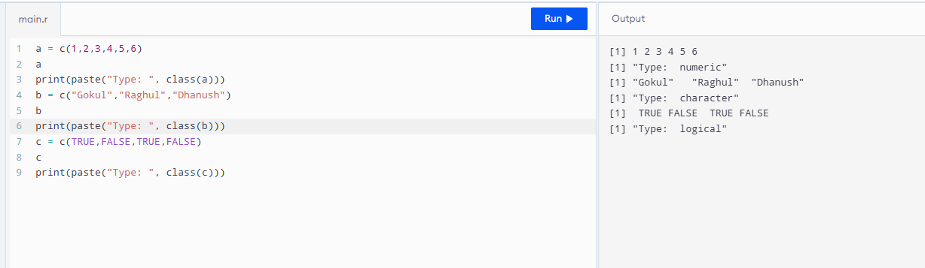
2. Create labelled matrices (5×4, 3×3, 2×2) filled by row/column.
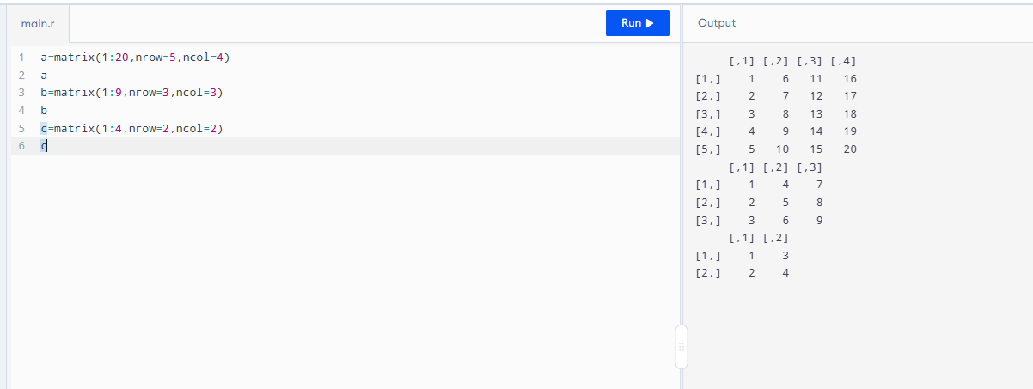
3. Write an R program to create and display a 3D array with specified rows,
columns, and tables.
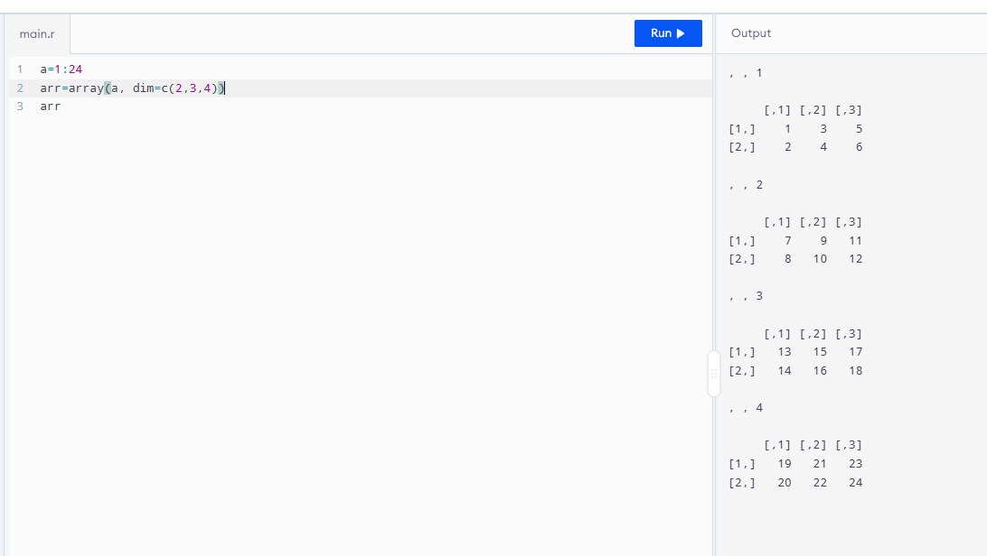
4. Create arrays from vectors with dimension names, print specific elements.
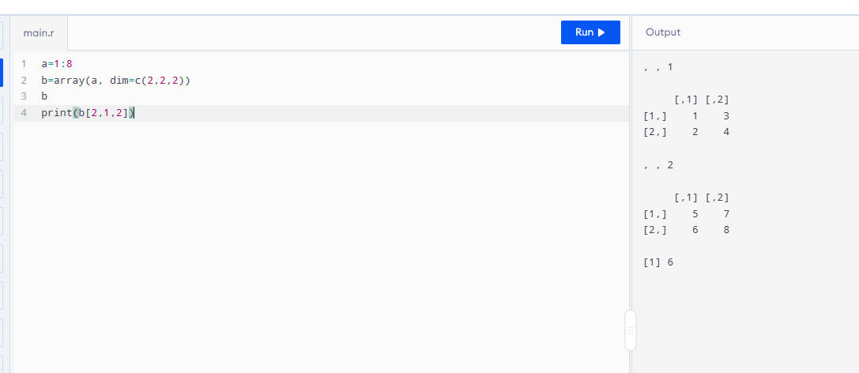
5. Create and manipulate factor variables (e.g., women’s dataset heights, random
LETTERS sample).
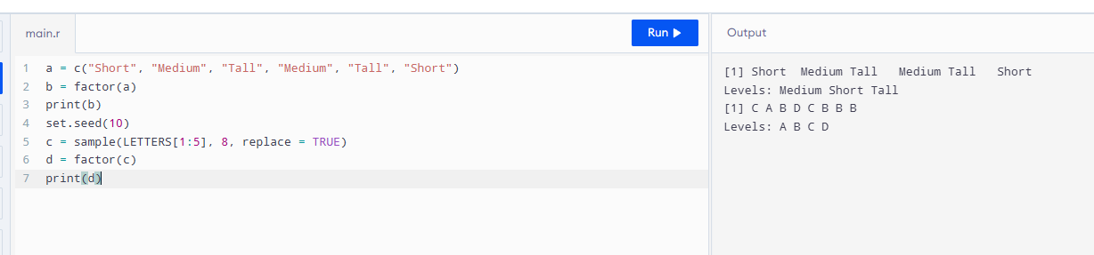
6. Create an R list containing vectors, matrices, and functions; display contents.
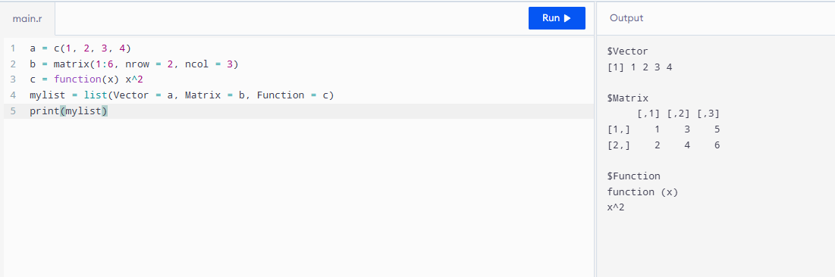
7.Write R programs for basic tasks: Factors of a number, generate a vector of 10random integers between -50 and 50, print numbers 1–100 with FizzBuzzlogic.
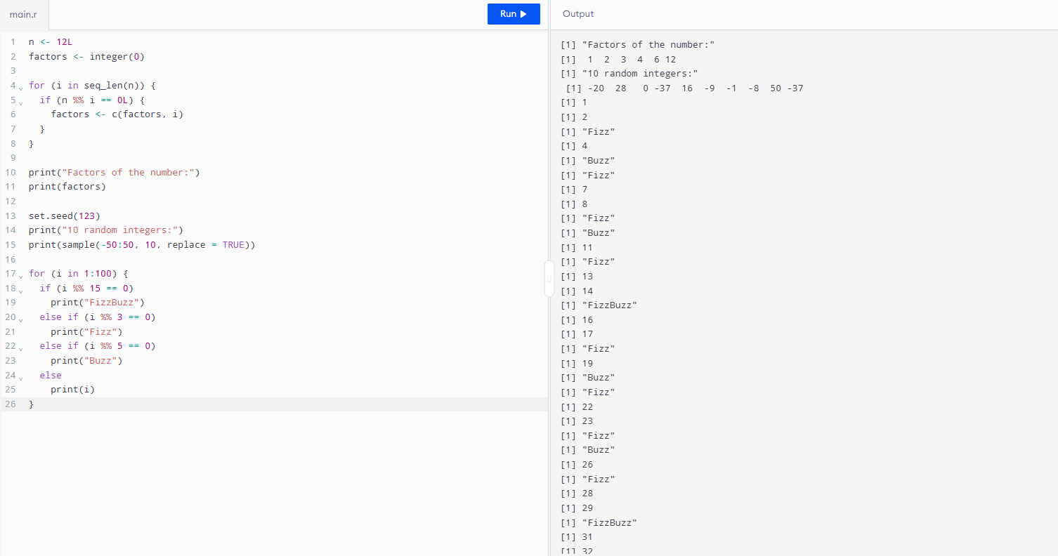
8. Generate random numbers from a normal distribution; count occurrences.
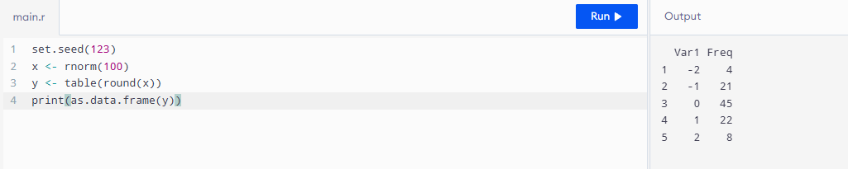
9. Create empty plots with specified axis limits.
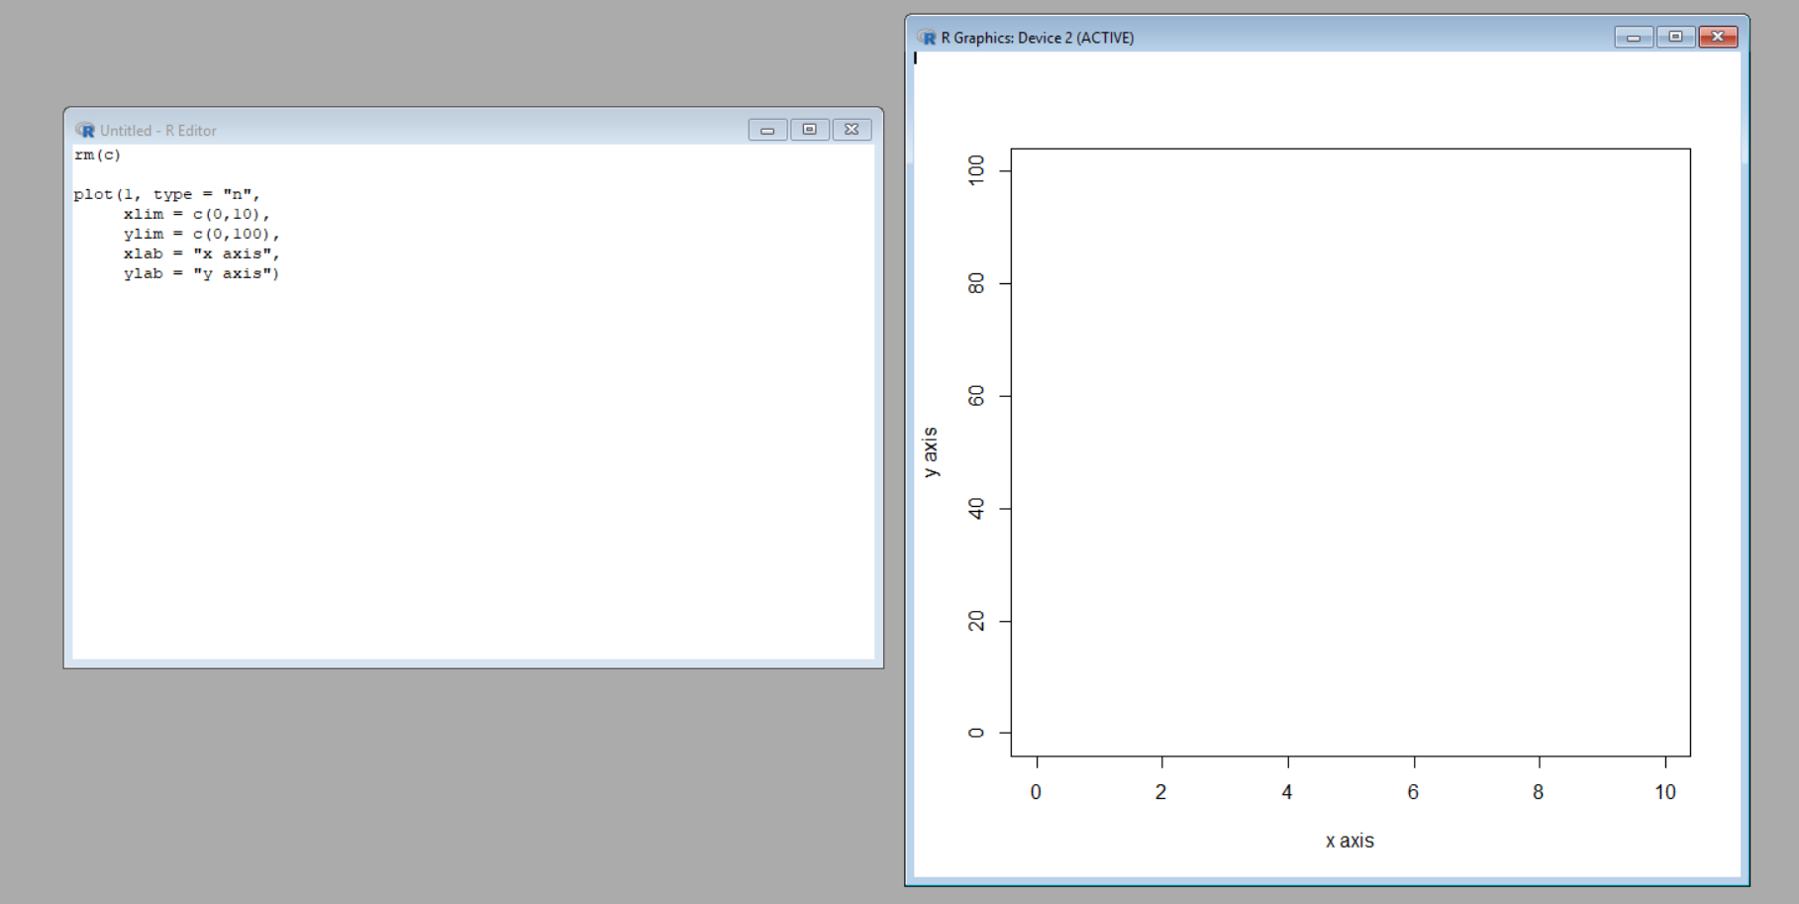
10. Create and explore a data frame exam_data with name, score, attempts, and qualifying fields. Perform extract, add row/column, sort, save to file.
